PRESS RELEASE

Martinez Historical Society
PO Box 14 (1005 Escobar Street)
Martinez, California

Date: September 12, 2014

Contacts: Carolyn Boone
Email: cfboone@aol.com
Telephone: (925) 864-8457

Janie Mori
Email: morijane@yahoo.com
Telephone: (925) 228-0158

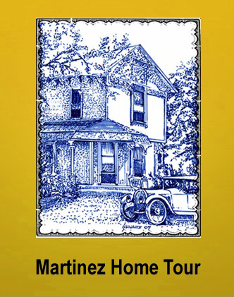

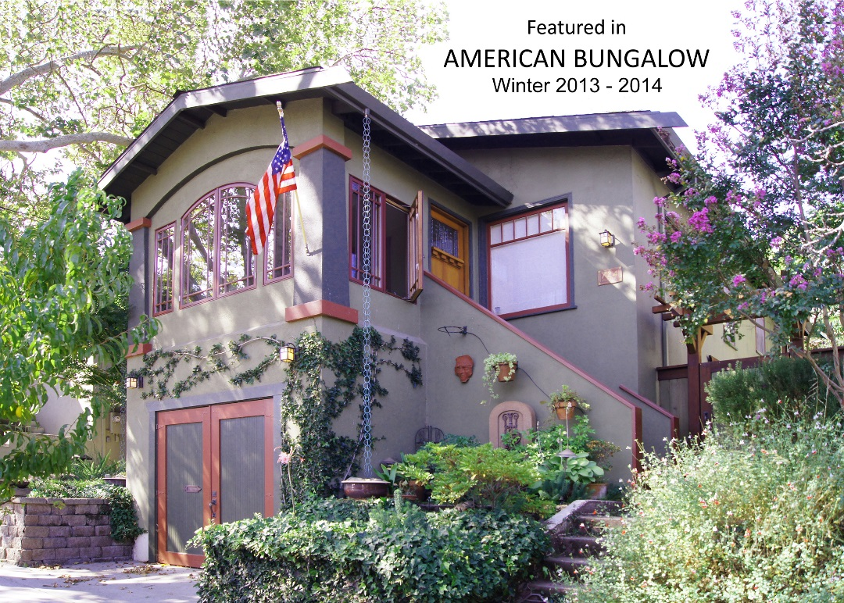
The restoration of this Craftsman home in Martinez was so successful that it was
selected as a feature home in the Winter edition of American Bungalow magazine.

Nationally Recognized Home to be on Tour

MARTINEZ – This year’s Historic Home Tour in Martinez will include the 1923 Craftsman bungalow pictured above. The restoration of the local house was so successful that it was one of four homes featured in the Winter Issue of American Bungalow. The magazine’s photo-rich article gave its readers across the USA a good description of the home and the restoration process. Now the Home Tour will allow local residents the opportunity to visit the home in person.

Restoration of the then-dilapidated house began when it was purchased in 2002. A generator was initially used because PG&E had turned off the power and gas three days after the house was purchased, deeming it unfit for habitation. During the ensuing restoration process, every piece of trim in the house was removed, refinished, and reinstalled. Missing Craftsman details, such as the built-in glass-faced bookcases which would have originally flanked the fireplace, were replaced. The oak floors were refinished. The kitchen was enlarged, and the impressive O’Keefe & Merritt stove was cleaned, re-chromed and re-enameled. The homeowner (Marc Hunter) did almost all the work himself after 5pm and on weekends. The effort to complete the project took over 12 years, but the result earned the Craftsman home a place in American Bungalow magazine, a first for a Martinez residence.

The Craftsman home style originated here in California around 1900. The more austere style was a reaction to the overuse of ornamentation and “gingerbread” in Victorian homes. The simpler Craftsman homes were so “honest” that they even revealed their structure to the onlooker -- in the form of exposed rafter tails and beam-ends or braces under the leaves. Tapered porch pillars were also a prominent feature. The Craftsman home was in vogue from 1905 to 1925, and the style virtually disappeared after the 1929 stock market crash -- and the onset of the Great Depression.

The interiors of Craftsman homes were intended to show off the skills of their craftsmen builders. Beautiful tiles surrounded fireplace openings. Rich, varnished woodwork is found throughout the houses. Leaded glass bookcases are common in living rooms. Built-in sideboards and china cabinets are found in dining rooms. Flooring was hardwood – upon which Persian carpets were displayed.

The Home Tour in Martinez will include six other vintage homes – none of which have previously been opened to the public. Five of the homes are in the Craftsman style, one is an English Cottage residence, and one is a Spanish Revival home. One of the Craftsman homes includes a hidden sleeping nook – one that is much cheerier than the gloomy “closet under the stairs” in which the young wizard, Harry Potter, was forced to sleep. The Spanish Revival home on the Tour is the mayor’s residence in Martinez. The Tour will also include the 1930 Masonic Temple which is an Art Deco structure, a period style often used for public buildings, but rarely for private homes. The Tour will start at the 1937 Shell Clubhouse and will include the town’s four museums.

The Historic Home Tour in Martinez will be held on Saturday October 11th from 10am to 4pm. The public is invited. More photographs and Tour information can be found on the website: www.MartinezHomeTour.com.

Please support our sponsors who make the Tour possible:

• Shell Martinez Refinery  • Shell Western States Federal Credit Union  • Dolan’s Lumber, Doors & Windows  • Republic Services (Allied Waste)  • Best Western Plus John Muir Inn  • State Farm Insurance, Matthew Rinn, Agent  • City of Martinez | • Cole Real Estate  • Shell Chemical Co.  • Hagin’s Automotive  • Bisio / Dunivan  • EcoMulch  • U.S. Bank  • Les Schwab Tires

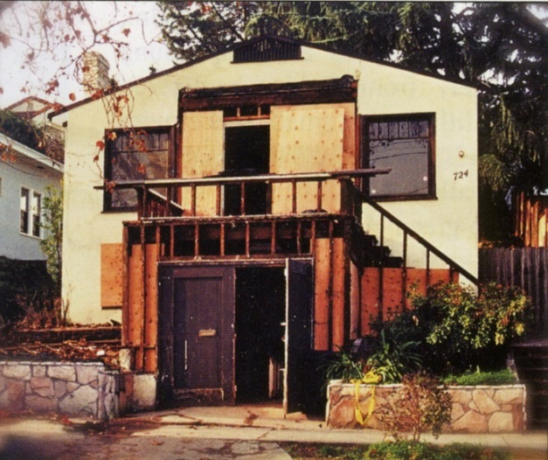
The once-condemned house before restoration began.
Courtesy of Leonard Hunter.

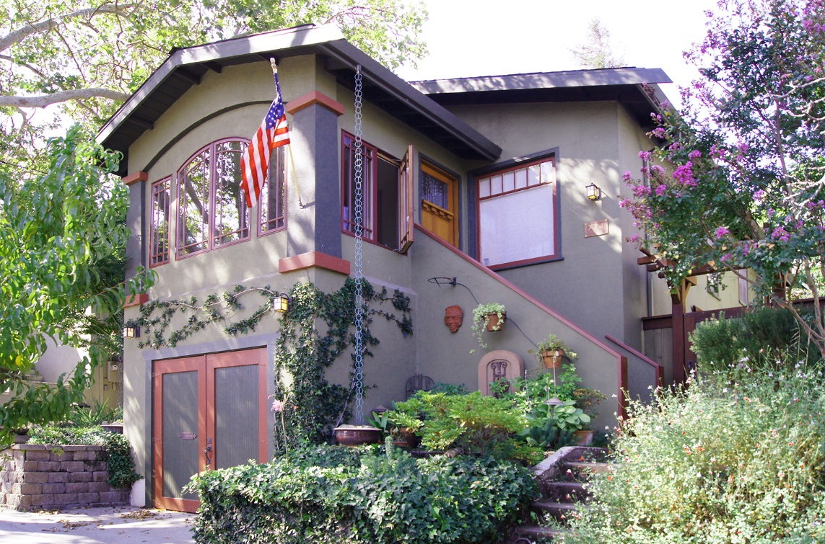
This beautifully restored Craftsman home in Martinez, constructed in 1923,
was featured in the Winter edition of American Bungalow magazine.
Courtesy of Carter Wilson.

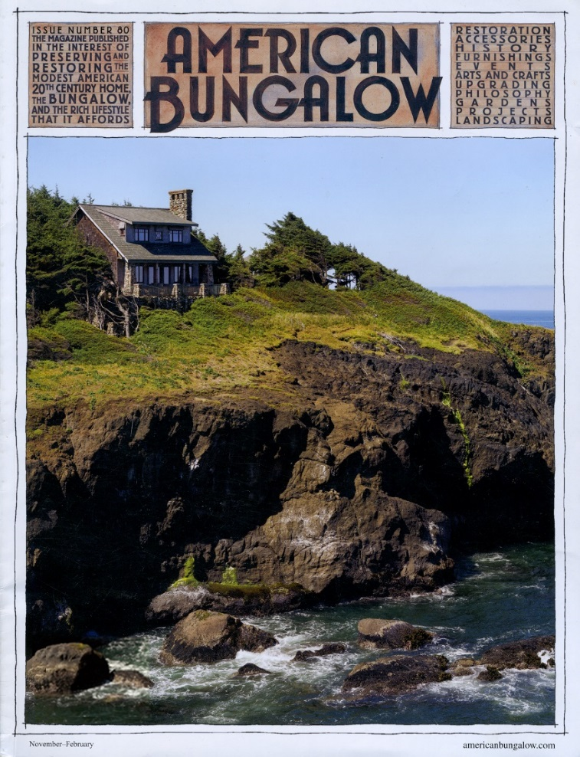
American Bungalow magazine featured its first home from Martinez, California
in its Winter 2013/2014 issue. The restored Craftsman home will be open to
visitors during the Historic Home Tour on Saturday October 11th.
For information, go to www.MartinezHomeTour.com

The warm, rich colors of the Craftsman era can be seen in the living room. Built-in leaded glass bookcases flank the fireplace, a method often utilized to showcase the craftsmanship that went into building a Craftsman home. Courtesy of American Bungalow.

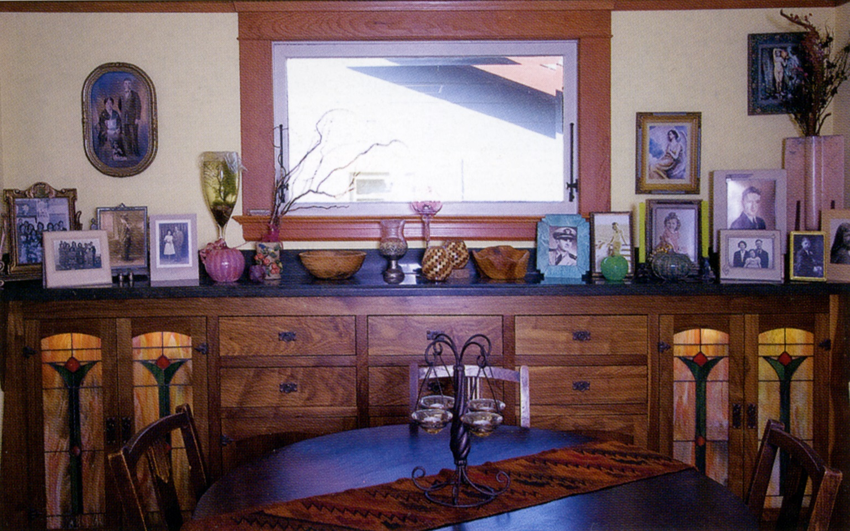
Craftsman Homes are known for the rich woodwork and built-ins shown in this dining room.
Courtesy of American Bungalow.
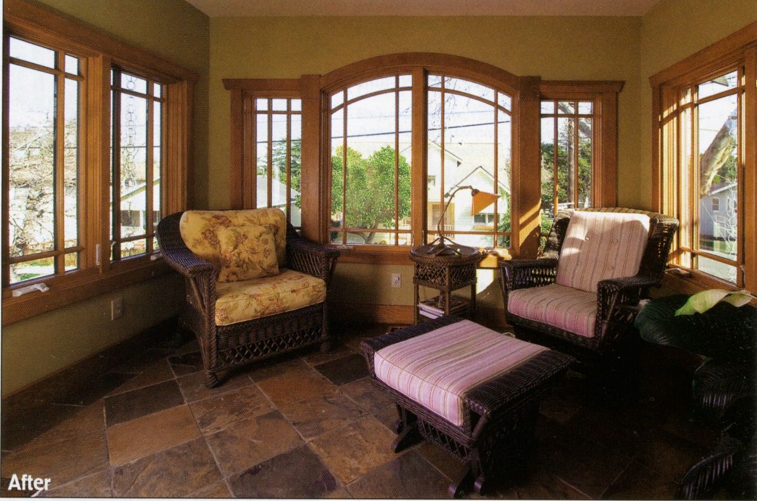
After the house was purchased, the original sunroom of the home was found to have such extensive dry rot that it had to be rebuilt. But the replacement faithfully incorporates Craftsman features and windows – and has been outfitted with period furniture. Courtesy American Bungalow.

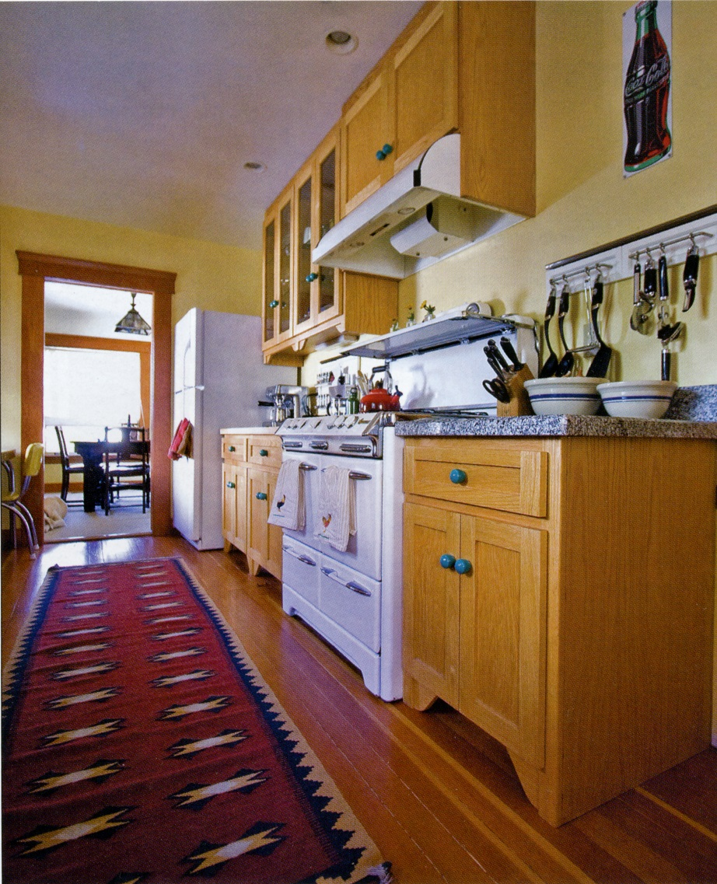
The beautiful O’Keefe & Merritt stove in the kitchen is quite the showpiece.
It has been rebuilt and functions perfectly. Courtesy of American Bungalow.

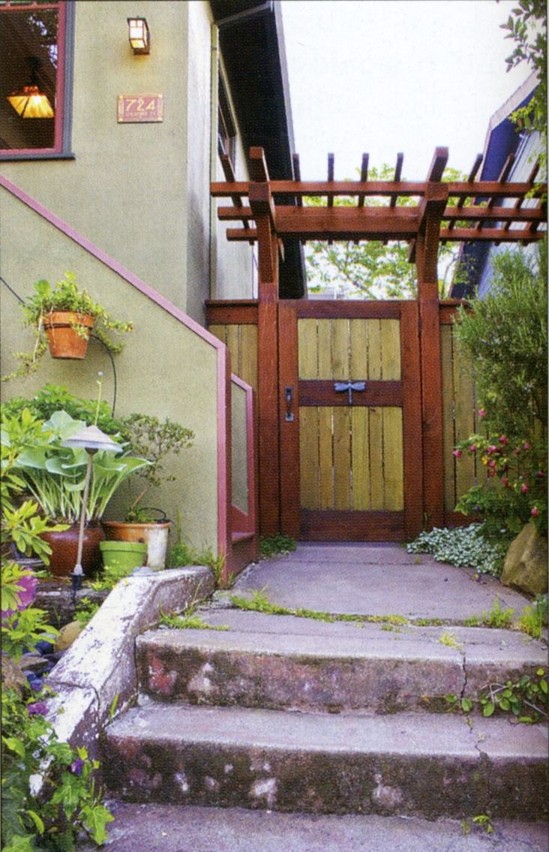
Arts & Craft details are incorporated into an inviting gate next which is located next to the front steps. The gate leads to a delightful outdoor living area behind the house. Courtesy of American Bungalow.

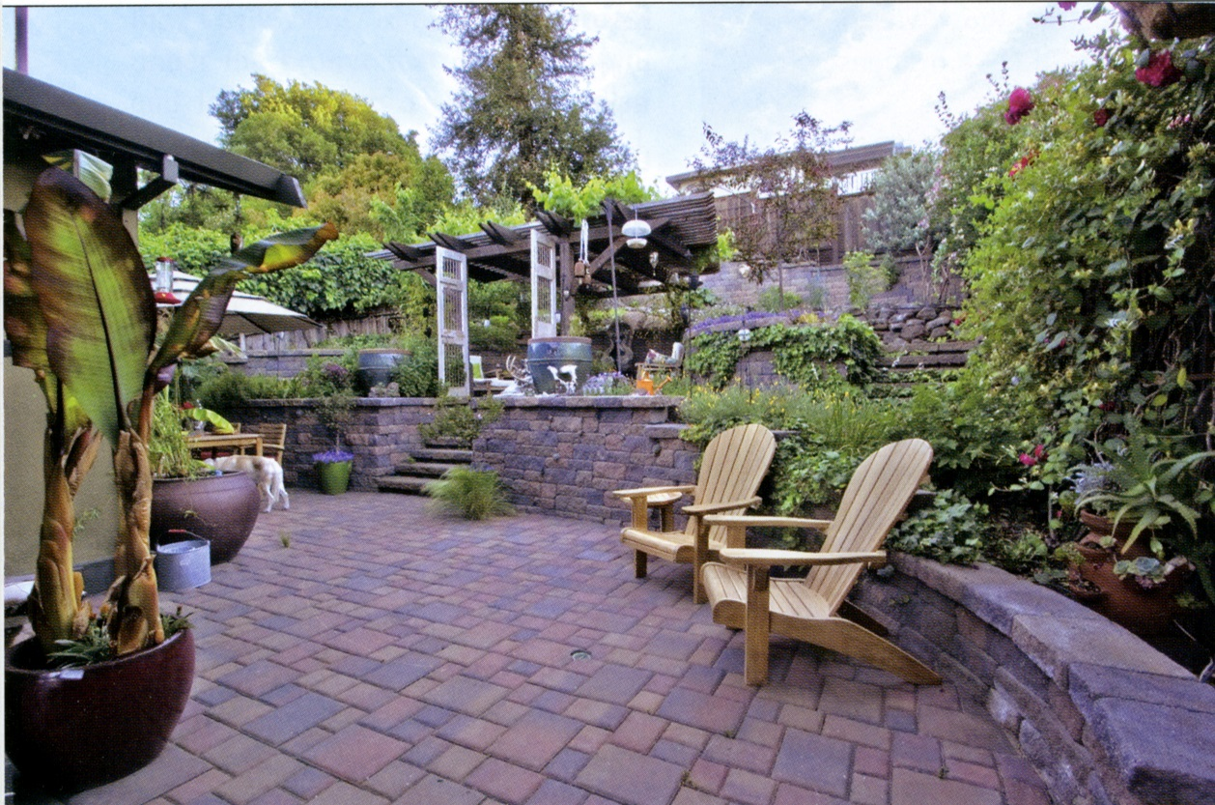
Bricks and pavers have been used behind the house to create level space in a rear garden that was formerly too steep to be useable for outdoor living. Courtesy of American Bungalow.

